Personal Information Technology
Year 11 Exam

Two (2) hours allowed including 10 minutes reading time
Return all paperwork

Handout Booklet

Time Allowed For This Paper
Reading time before commencing work: Ten minutes
Working time for paper: Two hours
Students may not leave within the first hour

Material Required / Recommended For This Paper
TO BE PROVIDED BY THE SUPERVISOR:
This Handout Sheet, a floppy disk if required
This Examination will take place on the computer you will save documents as directed Question / Answer File
Y11PIT Exam 2004.doc is located on the

Shared drive/ 2004/ Technology/Year 11/Y11PIT Exam 2004

Structure
Part One: (60 marks): Short Answer
Part Two: (30 marks): Essay
Presentation: (10 marks) (Marks are shown for each question)

IMPORTANT NOTE: Your file (yourname.doc) MUST be saved to your folder. The saved document will be marked after the exam if you DO NOT save your work it will result in a fail mark.

TO BE PROVIDED BY THE CANDIDATE:
Standard Items - Pen or pencils

Important Note To Candidates
No other items may be taken into the examination room.
It is your responsibility to ensure that you do not have any unauthorised notes or other items of a non-personal nature in the examination room. If you have any unauthorised material with you, hand it to the supervisor BEFORE reading any further. You may access the Graphics folders on the shared folder.

The following is not printed it is a file on the computer,
if the computers are down complete this paper by hand
Open Microsoft Word when instructed or after the Ten (10) minutes reading time:

Year 11 Exams

Personal Information Technology 2004

START OF EXAM

1. Your Name here: Rebecca Holliday
(2 marks)

2. FILE MANAGEMENT
In the Y11PIT Folder on your shared drive
Create a new folder and label it Y11PITExam 2004
Save this document as yourname.doc to this folder Do This NOW!
Regularly save your work to update your document
(5 marks)

3. Computers

Identify the following computer components
(9 marks)

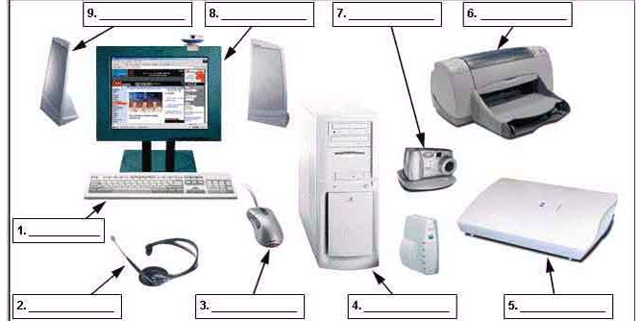

Answer Here

1. Keyboard | 6. Printer
2. Headphones | 7. Digital Camera
3. Mouse | 8. Computer Screen
4. Monitor | 9. Speakers
5. Scanner

4. List Two output devices (Insert a table to answer this question)
(2 marks)
Insert table here: -

CD/DVD Burner/Copier | Microphone

5. List two input devices (Insert a Tab between your answers)
(2 marks)
1. Floppy Disk Drive 2. CD Rom Drive

6. WORD PROCESSING

Improve the look of the following story:

The following story could look much better

Your task is to improve the look of the following story by correcting the spelling mistakes and use fonts and formatting to add emphasis or effect to certain areas.

Use of drop caps, borders or appropriate images may also improve you mark.

Add an appropriate picture from clip art and put it in the document of the text using text wrap.
All quotes should be italicised. The text needs to be justified and the heading should be more prominent.

Save your work now

Start on the next page_____________________________________________
(15 marks)

Some time ago, a mother punished her 5-year-old daughter for wasting a roll of expensive gold wrapping paper. Money was tight and she became even angrier when the child used all the gold paper to decorate a box to put under the Christmas tree.

As punishment the mother sent the child to bed without any supper.
Nevertheless, the little girl brought the gift box to her mother the next morning and said,

“This is for you, Momma.”

The mother still angry over her earlier reaction was ready to forgive, but her anger flared again when she opened the box and found it was empty. She spoke to her daughter in a harsh manner.

"Don't you know, young lady, when you give someone a present there's supposed to be something inside the package?”

With tears in her eyes her daughter said,

“Oh, Momma, it's not empty! I blew kisses into it until it was full.”

The mother was crushed. She fell on her knees and put her arms around her little girl, and she begged her for forgiveness for her thoughtless anger.

An accident took the life of the child only a short time later, and it is told that the mother kept that gold box by her bed for all the years of her life. Whenever she was discouraged or faced difficult problems she would open the box and take out an imaginary kiss and remember the love of the child who had put it there.

The Internet Searching the Web

- Describe briefly how search engines work?
(5 marks) Answer:

When searching for things in a search engine, you type in the word or topic that you want to search and the search engine finds pages from all over the world on the Internet on the particular topic, which you wanted.

- What are the three basic Internet search engines?
(3 marks) Answer:

1. AltaVista

2. Google

3. Yahoo

- Describe the strategies you can use to refine your searches?
(5 marks) Answer:

To refine your search you can type a + between your words to make sure that words are searched for in that particular order you typed them in eg: chritmas+pudding+recipies.

Most search engines have programs at the bottom of the search page you can click on and it narrows down your search a bit to make it easier to find the topics you want.

- List four other methods of finding information on the Internet that do not involve using a search engine.
(4 marks) Answer:

Other ways of finding things on the Internet are by typing in the web address and that would direct you to a certain page.

Excel Spreadsheets

11. A spreadsheet is a worksheet that resembles a table and is used for organizing numbers.
(1 mark) Answer: delete the answer that does NOT apply leaving one correct answer

True

12. An electronic spreadsheet file can contain this many worksheets.
(1 mark) Answer: delete the answers that do NOT apply leaving one correct answer

c. 225

13. On the spreadsheet diagram below show: (a) a row (b) a column (c) one cell (d) the range of cells F3:F9 (Draw arrows from the drawing toolbar pointing to the areas)
Answer: (draw lines to indicate)
(4 marks)

Row Column One Cell Range

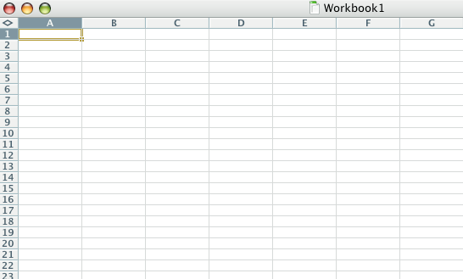
A
D

B
C

14. Columns and rows are used _____________.
(1 mark) Answer: delete the answers that do NOT apply leaving one correct answer

c. To organize data or information in a spreadsheet

15. Cells are referenced by _____________.
(1 mark) Answer: delete the answers that do NOT apply leaving one correct answer

d. Column letter and row number

Note: 10 additional marks will be awarded for presentation.

End of Part One.

Part Two Comprehension

16. Short Essay
(30 marks)

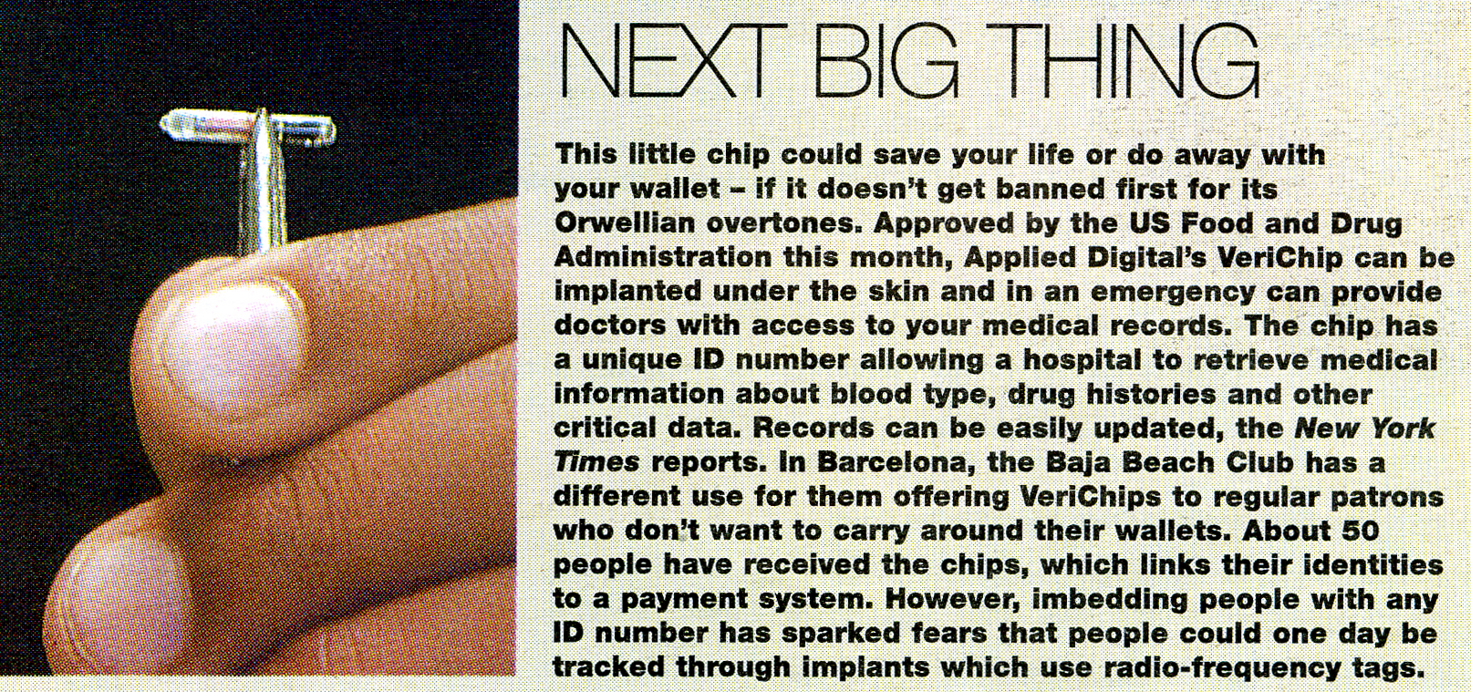

Note: George Orwell indicated in his book “1984” (written in the 1930’s) that all humans on the planet would one day be monitored by video and every word spoken would be recorded by a body called “Big Brother”. Subsequently nobody in the world would be free to speak against Big Brother!

Write a short essay about one or two pages on the above statement and answer the question:-

“Do you believe Personal Information Technology is moving towards a “Big Brother” world?”
“What do you see as the implications of similar technology like the VeriChip implant (above), digital phones, digital cameras, SMS text messaging, personal computers etc. will have on society in a modern world?”

Note this document should NOT include any spelling mistakes

Save your work

Type here:

With popular TV shows being introduced like reality TV show big brother I think that it is very likely that the world will turn into a so called “big brother” world.

Lately it has become more and more common for people to own and use computers, mobiles, video cameras, digital cameras and lots of other computerised devices.

It’s hard to believe that wherever you are someone could be watching you and listening to every word your saying. Nothing is strictly private anymore.

I think that in about 20-50 years time that the world is going to rely on computers so much that things like the VeriChip are going to become very common.

I don’t actually think the VeriChip is that bad of an idea. It could actually be very smart and one day save heaps of lives. If by some chance your wallet with all your identification details happens to get lost or stolen if its all recorded on a computer chip it’s a safe way to hold all your personal details as no-one is really going to be able to steal something that’s inside of you.

The world is becoming more and more and more computer generated and I wouldn’t be surprised if we did end up living under the command of “Big Brother”.

END OF EXAM

